Swim out of Region  Notification Form | 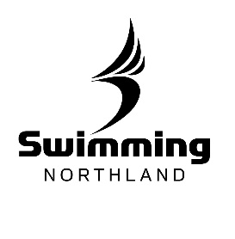

**Swimming is defined as competition, training, camps or coaching clinics

1. Place of event:

2. Date of event:

3. Reason for attending event:

6. Names of all officials and athletes (this must be a final list)
Club Name:
Manager:
Coach:
Coach Email Address:
Athlete/s:

Please post or scan this form to the following:

Rachel Bray
Swimming Northland Administrator
PO Box 564
Paihia, NZ
0247

admin@swimmingnorthland.org.nz

